

**Lab 2**

**Control systems**

|  |  |
| --- | --- |
| Nada Tarek Mowafi | 20012094 |
| Yasmin Yasser Mohamed | 20012216 |
| Section | 3 |

Design of Satellite-Tracking Antenna:

1. **Evaluate the closed loop transfer function:**
$$Jθ+ Bθ= K\left(θr - θ\right)$$

$$T(s)= θ/ θr= \frac{k}{Js^{2}+Bs+k}$$

2. **Use MATLAB to generate the state-space representation for the closed loop system for 𝐾 = 1:**

* Here is the code:

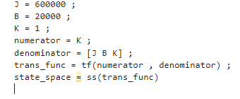

* The state space representation:

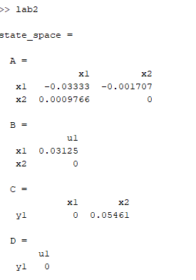

1. **What is the maximum value of 𝐾 that can be used if you wish to have a stable closed loop system?**
2. The **characteristic equation** for the system is:
$$Js^{2}+Bs+K=0$$

3. Stability conditions:
   * For a stable system, all coefficients of the characteristic equation must have the same sign.
   * Here, $J>0$, $B>0$ and $K>0$. As a result, the roots of the characteristic equation will always lie in the left-half of the complex plane for any $K>0$.
4. Behavior of Roots with Increasing K:
   * The roots are:
 $$s=\frac{-B ± \sqrt{B^{2}-aJK}}{2J}$$  * As K→∞ , the dominant root moves further left in the complex plane (s→−∞), and the system remains stable.

So, **No maximum value exists for K** , as the system remains stable for all K>0.

* Using matlab:

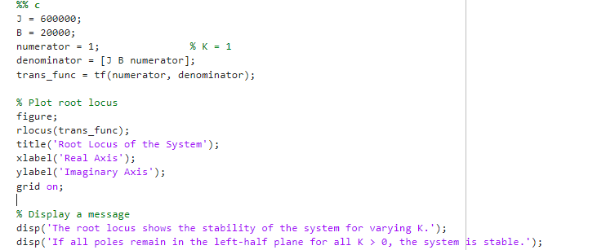

* 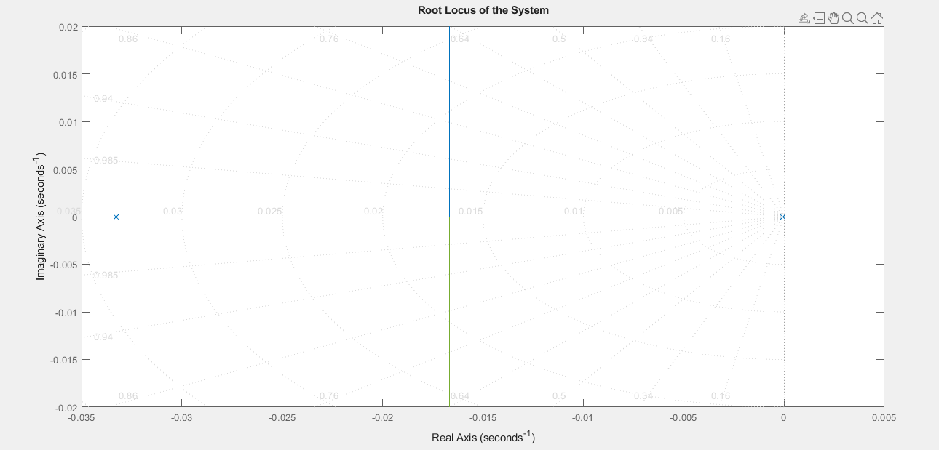The output:

1. What is the maximum value of 𝐾 that can be used if you wish to have an overshoot 𝑀𝑝 < 10%?

* Rearrange the overshoot formula to determine the required ζ:

$Mp<0.1$ ⟹ $ζ>0.591$

* For a second-order system, the damping ratio ζ is calculated as:
$$ζ= \frac{B}{2\sqrt{J ∙ k}}$$

* Here, the 2k comes from the characteristic equation:
$$Js^{2}+Bs+K=0$$

* Solve for K such that ζ>0.591:

$$ζ= \frac{B}{2\sqrt{J . 2k}}>0.591$$

$$\sqrt{J . 2k}<\frac{B}{2 ∙0.591}$$

$$K<\frac{B^{2}}{4J∙{0.591}^{2}}$$

$$k= \frac{{20000}^{2}}{4 ∙600000∙ 0.591}= 476.5.$$

Thus, the **maximum value of K** for Mp<10% is approximately 476.5.

* 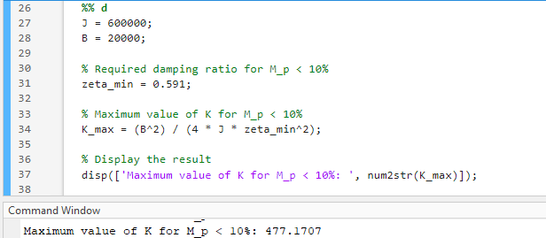Using matlab:

1. **What values of 𝐾 will provide a rise time of less than 80 sec? (Ignore the 𝑀𝑝 constraint.)**

For a standard second-order system, the rise time $tr$ ​ is approximately given by:

$$tr ≈ \frac{π- θ}{wn\sqrt{1-ζ^{2}}}$$

However, a more practical approximation for the rise time is:

$$tr≈ \frac{1.8}{wn}$$

where ωn ​ is the natural frequency of the system. The natural frequency ωn​ is related to the system parameters J, B, and K by the following equation:

$$wn =\sqrt{\frac{K}{J}}$$

Substitute tr <80 seconds:

$$80>\frac{1.8}{wn}$$

$$wn> 0.0225 rad/s.$$

Then ,

$$k>303.75$$

For the system to have a rise time tr <80 seconds, K must be greater than **303.75**.

* Using matlab:

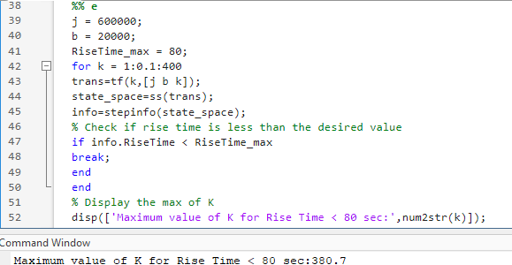

1. **Use MATLAB to plot the step response of the antenna system for 𝐾 = 200, 400, 1000, and 2000. Find the overshoot and rise time of the four step responses by examining your plots. Do the plots to confirm your calculations in previous parts?**
2. **Use MATLAB to plot the zeros and poles locations for each value of 𝐾 in part (e). comment on the effect of 𝐾 on the closed loop zeros and poles.**
3. **for each value of 𝐾 in part (e). find the steady state error.**

* 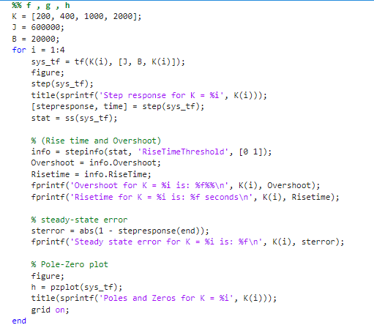**The code:**

* 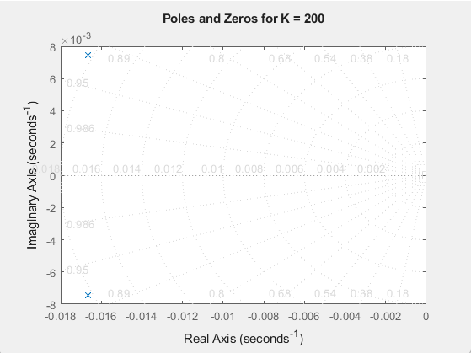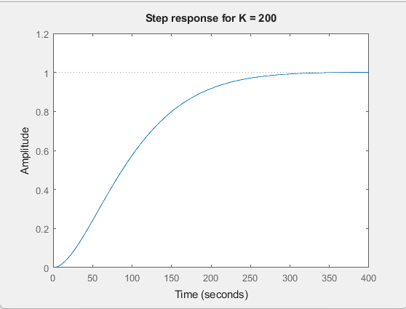**For k = 200:**



* 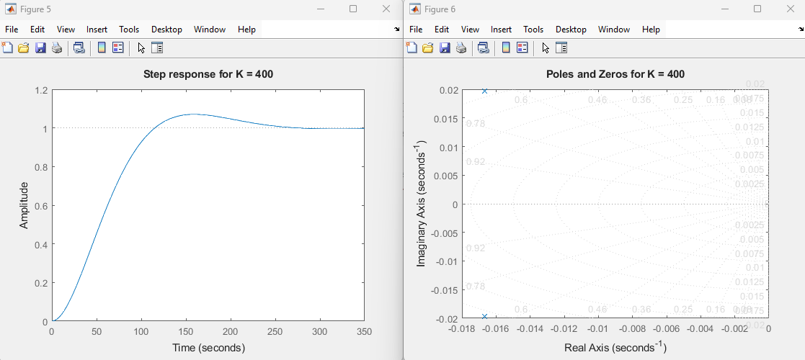For k = 400:



* **For k = 1000:**

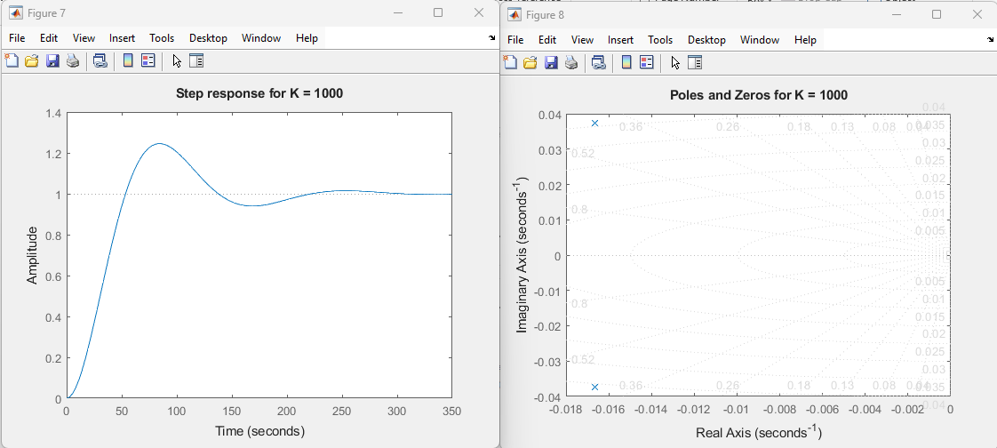



* For k = 2000:

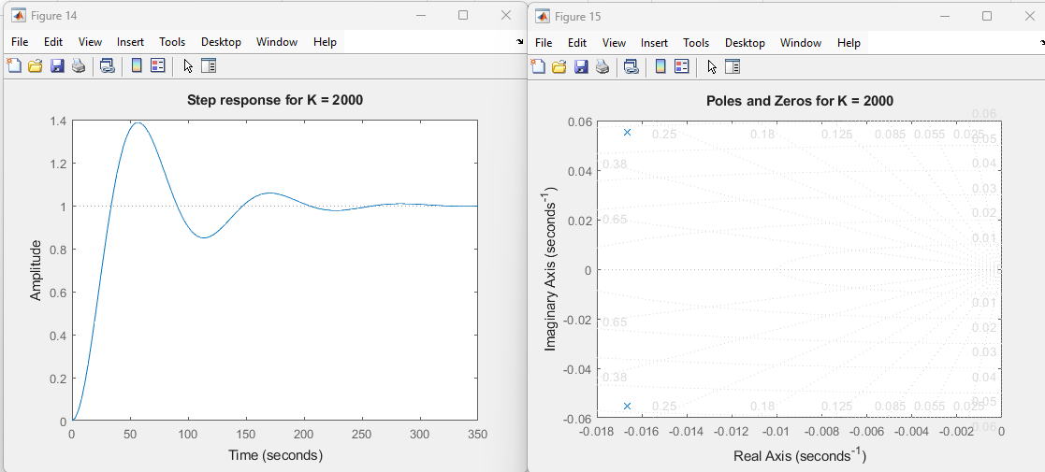



* **The comment on closed loop zeros and poles:**
* Increasing the value of K increases the poles value and they tend to move further left in the complex plane. This means the system becomes more stable. With the poles moving left, the system responds more quickly, reducing oscillations and settling faster. Essentially, increasing k makes the system less likely to "overshoot" and more likely to reach a steady state quickly.
* The zeros, which represent points where the system’s response is zero, are also influenced by K. When K increases, the zeros can move closer to the imaginary axis or, in some cases, shift toward infinity. The exact movement depends on the details of the system. In general, higher K values tend to make the system more responsive but can also impact how the system behaves in terms of stability and overshoot.